Will Arsenal finish first?

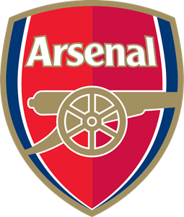

Arsenal London is a football club that has huge chance to win Premier League in season 2022/2023. In this paper I will try to explain why this London club has progressed so much during last few months. For the purpose of analysis data from fbref.com is used.

In my analysis I would like to answer to the following questions: